- Office of the -
Staten Island Borough President

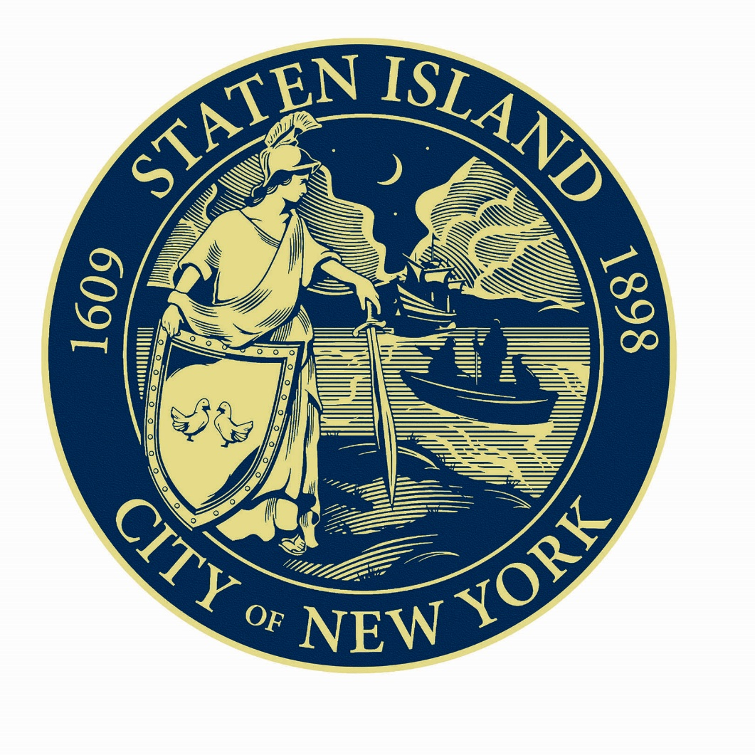
Local Law 12 of 2023
Proposed 5-Year Accessibility Plan
2024-2028

Table of Contents
General 3
Mission and Background of Agency 5
Executive Summary 6
Accessibility Statement 7
Agency Plan 8
Methodology 12
Appendix A 13

Local Law 12 of 2023
5-Year Accessibility Plan
Office of the Borough President, Staten Island

Local Law 12 of 2023 (“Local Law 12”), codified as section 23-1004 of the NYC Administrative Code, requires agencies to prepare and publish 5-year accessibility plans using a template provided by the Mayor’s Office for People with Disabilities (MOPD). The Office of the Borough President, Staten Island (the “Agency”) hereby publishes this proposed 5-year accessibly plan (the “Plan”) for public comment.

General

- Under Local Law 27 of 2016 (codified as NYC Admin Code § 23-1002), every city agency is required to appoint a Disability Service Facilitator (DSF) to coordinate its efforts to comply with and carry out its responsibilities under the ADA and other federal, state, and local laws and regulations concerning accessibility for persons with disabilities. The DSF shall serve as the primary contact within the agency for persons with disabilities requesting auxiliary services, coordinate auxiliary services for persons with disabilities, respond to inquiries from members of the public concerning accessibility, develop agency policies and procedures to ensure full programmatic and communication accessibility for persons with disabilities, conduct training for agency staff on disability access issues, provide accessible notices to members of the public advising of them of their rights and the agency’s grievance procedures, and document and assist in the investigation of complaints regarding noncompliance with the ADA and other applicable laws.

- Pursuant to Local Law 27 of 2016 (codified as NYC Admin Code § 23-1002) the name and contact information (including email, mailing address and phone number) of the Agency’s Disability Service Facilitator (DSF) is:

Name: | Heather A. DeMauro
Email: | accessibility@statenislandusa.com
Phone: | 718-816-2142
Address: | 10 Richmond Terrace, Staten Island, NY 10301

- The Personnel Office in conjunction with the General Counsel is the office responsible for preparing and updating the Agency’s 5-year plan;

- A link to the Agency’s notice of nondiscrimination / notice of rights, grievance procedure and website accessibility statement is here:

  - https://www.statenislandusa.com/
  - This is also attached herein as Appendix A

Mission and Background of Agency

The mission of the Agency is to advocate for the entire Borough of Staten Island and all its residents and represent the Borough’s interests within City government.

As a non-mayoral agency, the Agency achieves this mission by remaining committed to the recruitment, development, and retention of a diverse and inclusive workforce. To build a strong team and drive optimal performance on behalf of our constituents on Staten Island, the Agency encourages and values diversity of perspective, experience, and background.

Under Chapter 4 of the New York City Charter, the Agency is mandated to maintain a topographical bureau, recommend capital projects, monitor borough service delivery, establish a budget office, and establish a planning office that will assist in the development of land use and environmental matters. In addition, the Agency is responsible for the development of a strategic policy statement for Staten Island and may conduct public hearings and introduce legislation in the City Council.

The Agency, is made up of less than 40 employees, has made a deliberate effort, via policies and procedures, to promote a diverse work environment where all Agency employees, regardless of race/ethnicity/gender/age, or any other protected EEO status are treated with the same level of professionalism and respect. The Agency has implemented an open floor plan specifically to promote diversity, equal opportunity, and collaboration.

Executive Summary

Local Law 12 of 2023 (“Local Law 12”), codified as section 23-1004 of the NYC Administrative Code, requires agencies to prepare and publish 5-year accessibility plans using a template provided by the Mayor’s Office for People with Disabilities (MOPD). The Office of the Borough President, Staten Island (the “Agency”) hereby publishes this proposed 5-year accessibly plan (the “Proposed Plan”) herein. The Law contemplates five specific areas identified in section (b)(2) of Local Law 12 (NYC Admin Code § 1004(b)(2)): physical access, digital access, programmatic access, effective communications, and workplace.

Pursuant to the Agency’s responsibilities under city, state, and federal laws, the Agency is committed to making reasonable accommodations for applicants, employees, and program participants with disabilities. The ADA defines a person with a disability as a person who has a physical or mental impairment that substantially limits one or more major life activity. This includes people who have a record of such an impairment, even if they do not currently have a disability. It also includes individuals who do not have a disability but are regarded as having a disability. The ADA also makes it unlawful to discriminate against a person based on that person’s association with a person with a disability.

Further the Agency is continuing to conduct self-evaluations in one or more of the areas set forth in the Local Law 12 to achieve the goals set forth in this Plan. The Agency strives to ensure that persons with disabilities are included and can participate effectively in government functions.

Accessibility Statement

The Agency is committed to maintaining a workplace accessible to persons with disabilities.

The Agency through its DSF coordinator will endeavor to find new ways accessibility fits within the Agency’s operations and activities both inside and outside of its office as the situation shall dictate.

It is the policy of the Office of the Borough President, Staten Island (the “Agency”) to comply with all applicable laws including, but not limited to, the Americans with Disabilities Act (ADA), Rehabilitation Act, the New York State Human Rights Law, and the New York City Human Rights Law (NYCHRL). Office of the Borough President, Staten Island does not discriminate on the basis of disability in the operation of its hirings, programs, services and activities.

The Agency expects all managers and supervisors to promote a work environment that is fair, safe, and accessible for all persons with disabilities—and one that regards accessibly, inclusion, and respect for all.

Agency Proposed Plan

As Local Law 12 requires the Agency to publish a plan describing the steps it is currently taking and will take over the next 5 years to ensure that the Agency’s workplace, services, programs, and activities are accessible to and accommodating and inclusive of persons with disabilities, the following are five (5) areas required to be identified in section (b)(2) of Local Law 12 (NYC Admin Code § 1004(b)(2):
- Physical Access
- Access Issues: The Agency is housed within a DCAS-managed building. Please see DCAS’s 5-year plan for information on the common areas of the building.. The Agency space is comprised mostly of Agency staff offices. Spaces that members of the public visit are generally accessible to persons with physical disabilities.

- Actions: The Agency will explore ordering and installing additional signage (including braille signage) to address any gaps between the DCAS common areas and the Agency-specific areas. Although, DCAS is responsible for maintaining the common areas of the building, the Agency makes efforts to monitor the areas of the building to ensure that the building operations can run smoothly and to ensure that there are no barriers to accessibility. When the Agency identifies an issue, the Agency promptly notifies DCAS if maintenance is required and to ensure a timely remediation of the issue.

- Digital Access
  - Action Issues: During its agency-wide review prompted by Local-Law 12, it was determined that the Agency’s website did not contain an accessibility statement. Further, the website itself, may not have been fully accessible for those who are blind or have low vision and compliant with the standards adopted under Local Law 26 of 2016 (currently, the Web Content Accessibility Guidelines (WCAG) 2.1 Level AA).

  - Actions: The Agency has posted a website accessibility statement and is continuing to work to ensure that its website meets applicable standards and to improve the accessibility of its digital content, including electronic documents and social media. Specifically, the Agency is working with Job Access With Speech (JAWS) software to test and ensure the Agency’s website is accessible for individuals who use screen readers. The Agency is also developing processes to ensure that videos shared with the public include captioning and that electronic documents shared with the public are accessible, including that images always include Alt text.

- Programmatic Access
- Access Issues: Agency rarely is solely responsible for event notices as events are held in partnership with other governmental and non-governmental entities. However, such event notices may not include information about accessibility features and how to request additional accommodations.
- Actions: Event notices will include information required under Local Law 28 of 2016, including information on accessibility features that are being provided as a matter of course, as well as information on how to request a reasonable accommodation

- Effective Communications
- Access Issues: The Agency may not have adequate mechanisms in place to provide CART, ASL interpretation, and large print and Braille expeditiously on request. Additionally, digitally distributed items may not meet MOPD guidance.

- Actions: The Agency is working to ensure that it has mechanisms in place to expeditiously provide CART, ASL interpretation, large print and Braille and other auxiliary aids and services upon request. Additionally, it is working to ensure that videos shared with the public include captioning and that electronic documents shared with the public are accessible, including that images include always include Alt text, Further, the Agency’s EEO Office – including the DSF- will continue to maintain an open-door policy and respond to all inquiries from employees, prospective employees, and members of the public as such inquiries are received. This includes any accommodation requests from persons with disabilities. All departments work effectively and efficiently to ensure that services, programs, and activities are accessible and inclusive for all constituents including persons with disabilities.

- Workplace Inclusion
- Access issues: All employees and prospective employees are provided with equal employment opportunities irrespective of their protected categories. All prospective employees are encouraged to apply to open listings and job opportunities, and such applicants are apprised of their right to reasonable accommodations should they request such an accommodation throughout the application and interviewing process.

- Actions: The Agency will explore posting eligible employment positions on the NYC: ATWORK job board and engaging in other recruitment specifically targeted to people with disabilities.. The Agency is also working with MOPD to ensure that Agency staff receive Disability Etiquette and Awareness trainings as applicable. Additionally, the EEO Office ensures that all employees are given the City Equal Employment Opportunity Policy along with information about the reasonable accommodation process and the complaint process. Annually, the EEO Office includes information about the reasonable accommodation process and the complaint process via the monthly EEO Newsletter. The EEO Office maintains an open-door policy and responds to all inquiries from employees, prospective employees, and members of the public as such inquiries are received.

Methodology

The Agency assessed the access issues identified herein by the Personnel Office in conjunction with the General Counsel and Agency staff, including staff members with family and friends with disabilities.
Additionally, since the Agency is physically housed in a DCAS building, a member of the DCAS building management team was consulted regarding access for persons with physical disabilities. The Agency looks forward to receiving feedback from constituents with disabilities as part of the public comment process.

Appendix A

AGENCY’S NOTICE OF NONDISCRIMINATION / NOTICE OF RIGHTS
OFFICE OF THE BOROUGH PRESIDENT, STATEN ISLAND (THE “AGENCY”) POLICIES PROHIBITING DISCRIMINATION AGAINST PEOPLE WITH DISABILITIES IN ACCESS TO CITY SERVICES
It is the policy of Office of the Borough President, Staten Island to comply with all applicable laws including, but not limited to, the Americans with Disabilities Act (ADA), Rehabilitation Act, the New York State Human Rights Law and the New York City Human Rights Law. Office of the Borough President, Staten Island does not discriminate on the basis of disability in the operation of its programs, services and activities.
Employment related complaints for employees and applicants for employment seeking a reasonable accommodation are covered under the City’s Diversity, Local Law 12, and EEO Policy which can be found at http://www.nyc.gov/html/dcas/html/about/eeo.shtml.
Any member of the public who requires an auxiliary aid or service for effective communication, or a reasonable modification of policies or procedures (involving matters other than employment) in order to participate in our programs, services or activities is invited to direct their needs and preferences to Heather A. DeMauro, Disability Service Facilitator (“Facilitator“) by mail, telephone, or email:
Disability Service Facilitator
Heather A. DeMauro
10 Richmond Terrace
Staten Island, NY 10301
(p) 718-816-2142 | (e) accessibility@statenislandusa.com
TTY: 212-504-4115 NYC 311 TTY Number
New York Relay Service 711

Requests should be made as soon as possible but no later than three (3) business days before the scheduled program, service or activity. Questions, concerns or requests for additional information may be directed to Heather A. DeMauro, Facilitator.
If you believe that you have been denied an auxiliary aide or service or a reasonable modification of policies or procedures in order to participate in programs, services or activities provided by Office of the Borough President, Staten Island please see Office of the Borough President, Staten Island grievance procedure.

AGENCY’S GRIEVANCE PROCEDURE
OFFICE OF THE BOROUGH PRESIDENT, STATEN ISLAND GRIEVANCE PROCEDURE UNDER THE AMERICANS WITH DISABILITY ACT, THE REHABILITATION ACT AND STATE AND CITY HUMAN RIGHTS LAWS IN ACCESS TO CITY SERVICES
This grievance procedure may be used by any member of the public who wishes to file a grievance alleging discrimination on the basis of disability in the provision of services, activities, programs or benefits by the Office of the Borough President. Employment related complaints for employees and applicants for employment seeking a reasonable accommodation are covered under the City’s Diversity and EEO Policy which can be found at http://www.nyc.gov/html/dcas/html/about/eeo.shtml.
The grievance should be in writing and contain information about the alleged discrimination such as the name, address, and telephone number of the grievant, as well as the location, date, and description of the complaint or alleged violation of the ADA, the Rehabilitation Act, the New York State Human Rights Law or the New York City Human Rights Law. Examples of discrimination include, but are not limited to an agency refusing to provide an American Sign Language interpreter, large print or Braille documents and real time captioning also known as computer-assisted real-time transcription (CART) when requested within a reasonable time frame or failing to provide adequate information regarding accessibility for people with disabilities at Office of the Borough President hosted public events.
Alternative means of filing grievances, such as in-person interviews or an audio recording of the grievance, may be made available, as needed, to persons with disabilities upon request.
The grievance should be submitted as soon as possible but no later than sixty (60) calendar days after the date of the alleged violation of the ADA, the Rehabilitation Act, the New York State Human Rights Law or the New York City Human Rights Law to:
Disability Service Facilitator
Heather A. DeMauro
10 Richmond Terrace
Staten Island, NY 10301
(p) 718-816-2142 | (e) accessibility@statenislandusa.com
TTY: 212-504-4115 NYC 311 TTY Number
New York Relay Service 711

Within thirty (15) calendar days after receipt of the grievance, the facilitator or his or her designee will contact the grievant to discuss the grievance and any possible resolutions.
Within fifteen (15) calendar days of this contact with the grievant, the facilitator or his or her designee will respond to the grievance in writing or, where appropriate, in a format accessible to the grievant, such as large print, Braille, or audio recording. This response will explain Office of the Borough President’s position and offer options for substantive resolution of the grievance, where applicable.
The grievant or the grievant’s designee may appeal the decision by the facilitator or his or her designee within thirty (30) calendar days of receipt of the response by mail to:
Borough President Vito Fossella
Office of Staten Island Borough President Vito Fossella
10 Richmond Terrace
Staten Island, NY 10301
The appeal should be submitted in writing. Alternative means of filing an appeal, such as an in-person interview or an audio recording of the grievance, may be made available for persons with disabilities upon request.
Office of the Borough President, Staten Island’s response to the appeal will be provided to the grievant within sixty (60) days following receipt of the request for the appeal. All responses by the Office of the Borough President, Staten Island will be in writing or, where appropriate, in a format accessible to the grievant. All written grievances, appeals, and responses received in connection with a grievance made to Office of the Borough President, Staten Island, will be retained for at least three (3) years. This document is available in alternative formats, including large print, audio recording, and Braille, from the facilitator upon request.

AGENCY’S WEBSITE ACCESSIBILITY STATEMENT
Staten Island Borough President Website Accessibility Statement
The Office of The Staten Island Borough President is committed to ensuring its digital content is accessible to and usable by people with disabilities. We are continually improving the user experience for everyone and applying the relevant accessibility standards.
Conformance Status
The Web Content Accessibility Guidelines (WCAG) defines requirements for designers and developers to improve accessibility for people with disabilities. It defines three levels of conformance: Level A, Level AA, and Level AAA. Our digital content is partially conformant with WCAG 2.1 level AA. Partially conformant means that some parts of the content do not fully conform to this accessibility standard.
Feedback
If you need assistance accessing a particular program or service, please reach out to the Office of The Staten Island Borough President’s Disability Services Facilitator at accessibility@statenislandusa.com.
Assessment Approach
The Office of The Staten Island Borough President assesses the accessibility of its digital content through self-evaluation.
Date
This statement was created on 12/19/2023.

